Analyzing The Performance & Efficiency Of The Pravin Hotels Using Data Visualization Techniques

INTRODUCTION;

1.1 OVERVIEW

Welcome to the world of data-driven decision making! In today's competitive business landscape, organizations are constantly seeking ways to improve their performance and efficiency. Pravin Hotels, a leading hospitality chain, is no exception. To stay ahead in the market, Pravin Hotels recognizes the importance of harnessing the power of data visualization techniques to gain insights and make informed decisions.

In this analysis, we will explore how data visualization techniques can be utilized to evaluate the performance and efficiency of Pravin Hotels. By leveraging data from various sources, such as customer reviews, revenue data, and operational metrics, we will delve into the world of data visualization to uncover hidden patterns, identify areas of improvement, and optimize operations.

Data visualization is a powerful tool that allows us to present complex data in a visually appealing and intuitive manner. Through charts, graphs, and interactive dashboards, we can transform raw data into meaningful insights that can drive strategic decision-making. By examining key performance indicators (KPIs) and conducting in-depth analyses, we will gain a comprehensive understanding of Pravin Hotels' current performance and efficiency levels.

1.2 PURPOSE

The purpose of analyzing the performance and efficiency of Pravin Hotels using data visualization techniques is to gain insights and make data-driven decisions to optimize operations and improve overall business performance. By utilizing data visualization techniques, the analysis aims to visually represent data related to various aspects of Pravin Hotels' operations, such as revenue, occupancy rates, customer satisfaction, employee performance, and other relevant metrics.

The primary objectives of this analysis include:

1. Performance Evaluation: Data visualization techniques can provide an overview of Pravin Hotels' performance by presenting key performance indicators (KPIs) in a visually appealing and easy-to-understand manner. By analyzing these visual representations, stakeholders can assess how well Pravin Hotels is performing in terms of revenue generation, customer satisfaction, and operational efficiency.
2. Identify Patterns and Trends: Data visualization techniques enable the identification of patterns and trends in the data that may not be apparent through other means. By visually examining data, stakeholders can identify patterns or trends that may reveal insights and opportunities for improvement. For example, visualizing data on occupancy rates over time may reveal seasonal patterns or identify periods of low or high demand, which can inform strategic decisions such as pricing adjustments or marketing campaigns.
3. Benchmarking and Comparison: Data visualization techniques can facilitate benchmarking and comparison of Pravin Hotels' performance against industry standards or competitors. By comparing key metrics with industry benchmarks or competitors' performance, stakeholders can assess how Pravin Hotels is performing relative to its peers and identify areas where it may be lagging or excelling.
4. Decision Making: Data visualization techniques can support data-driven decision-making by presenting complex data in a visually intuitive manner. By visually analyzing data related to various aspects of Pravin Hotels' operations, stakeholders can make informed decisions about resource allocation, process optimization, and strategic planning to enhance performance and efficiency.
5. Communication and Reporting: Data visualization techniques can simplify the communication and reporting of complex data to different stakeholders, such as senior management, investors, and employees. Visual representations of data can facilitate effective communication, enhance understanding, and support consensus building among stakeholders, leading to more informed and effective decision-making.

2 PROBLEM DEFANITION AND DESIGN THINKING

2.1 EMPATHY MAP

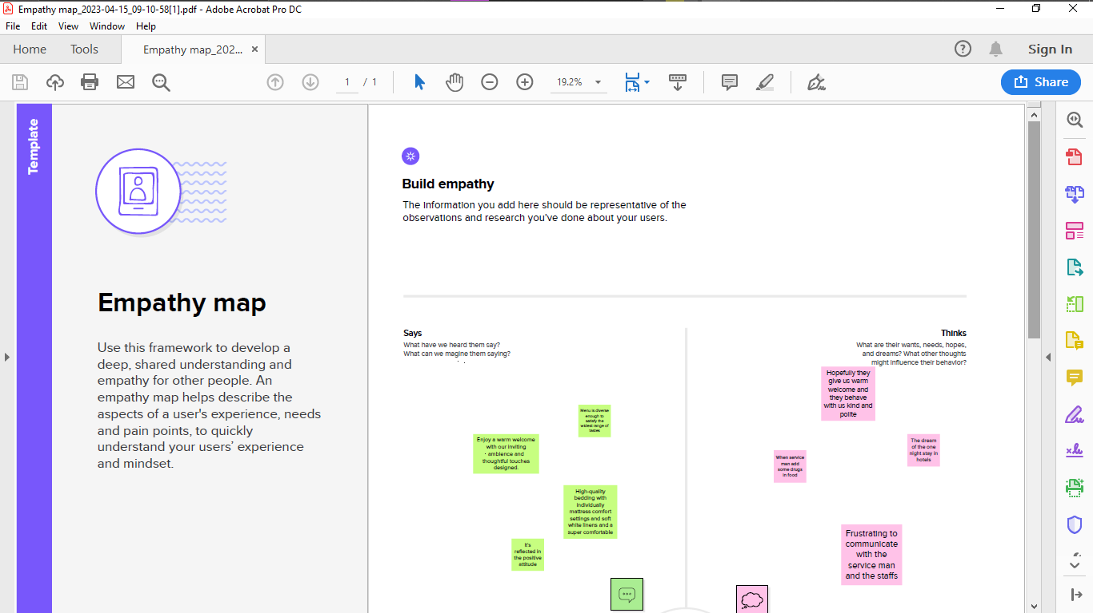

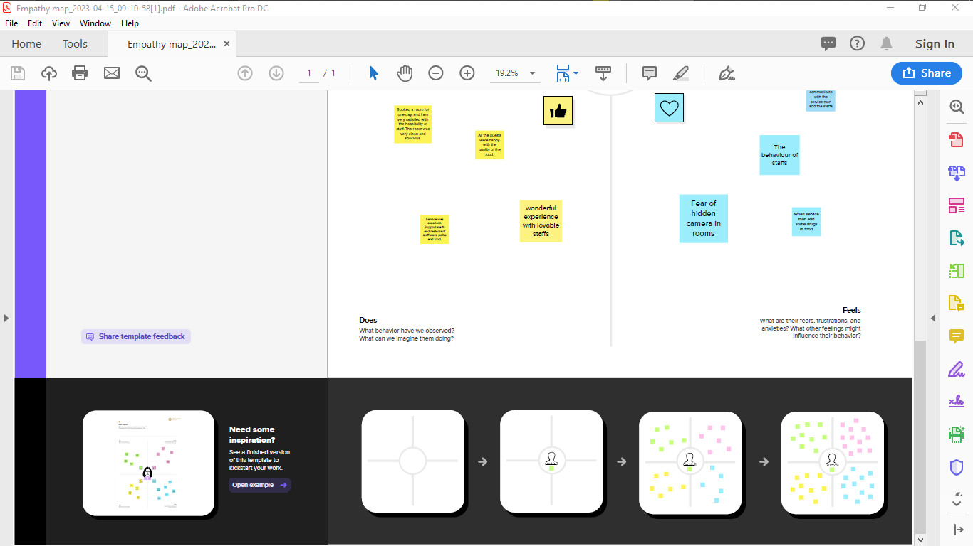

2.2 BRAINSTROMING MAP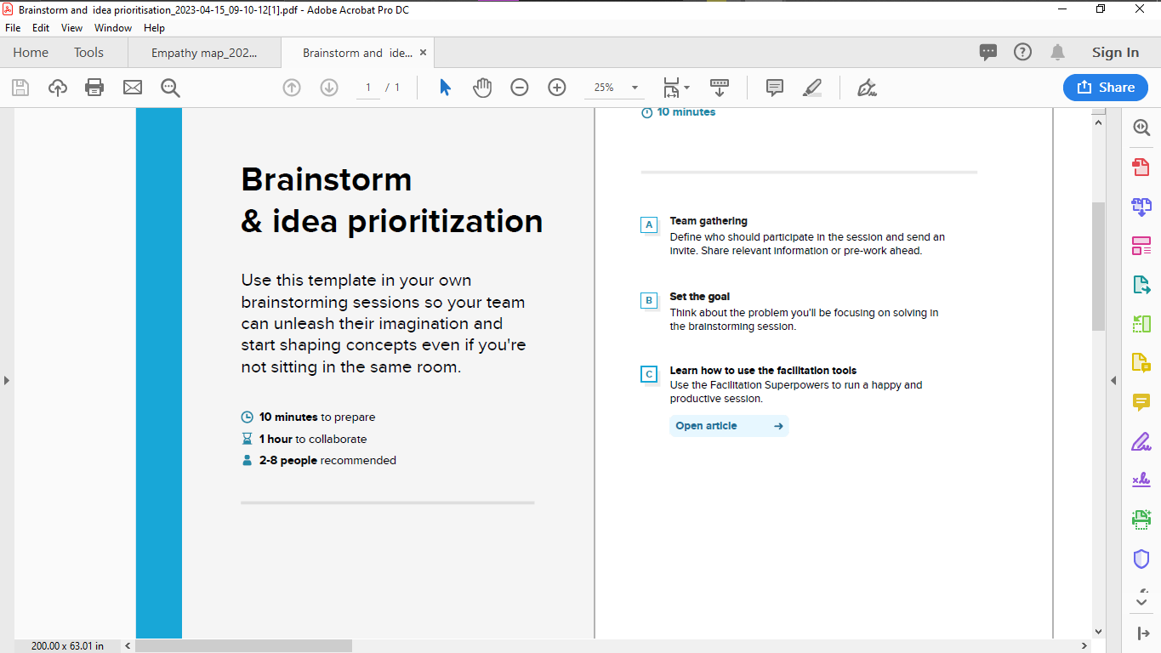

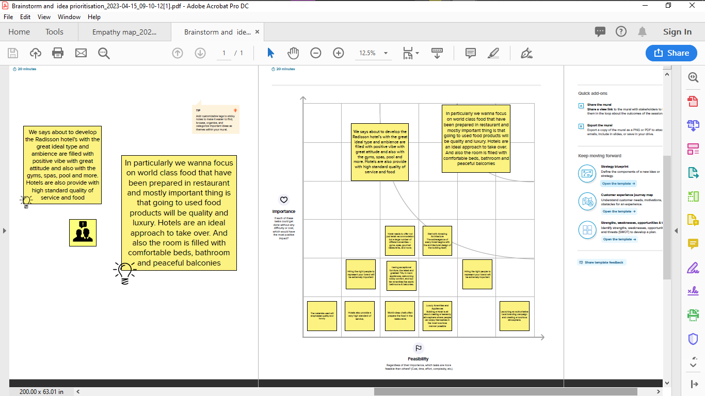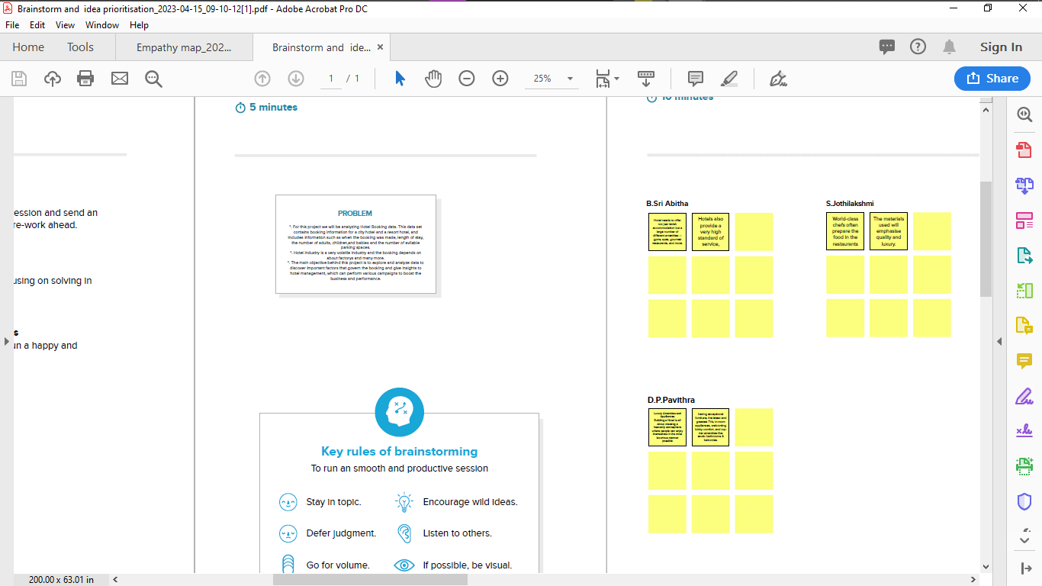

3 RESULT

OUTPUT OF THE RESULT

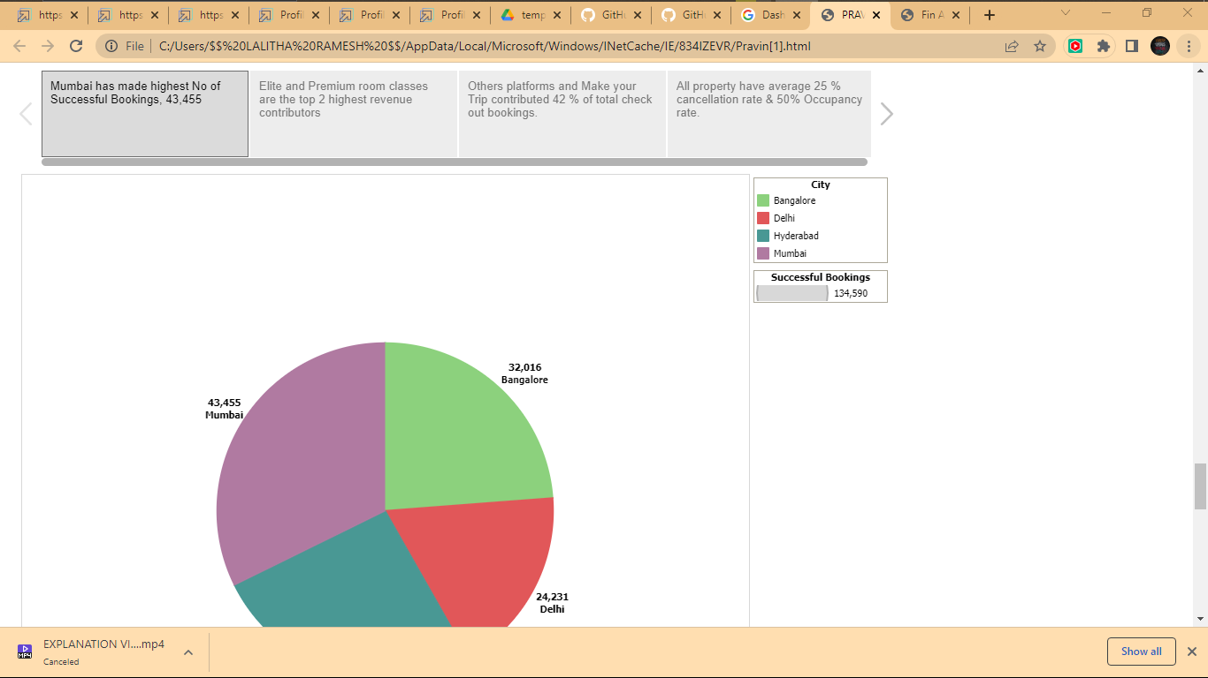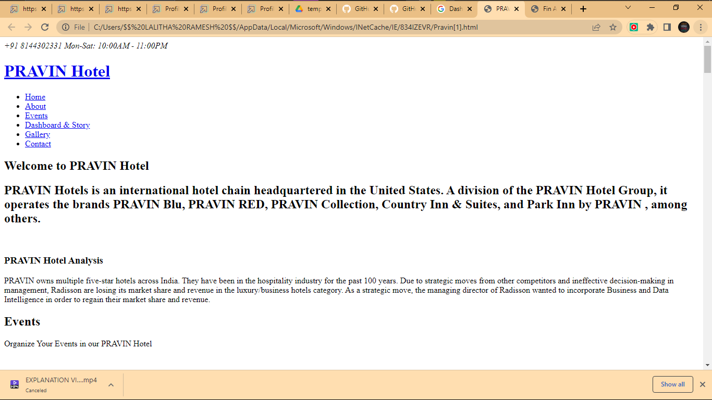

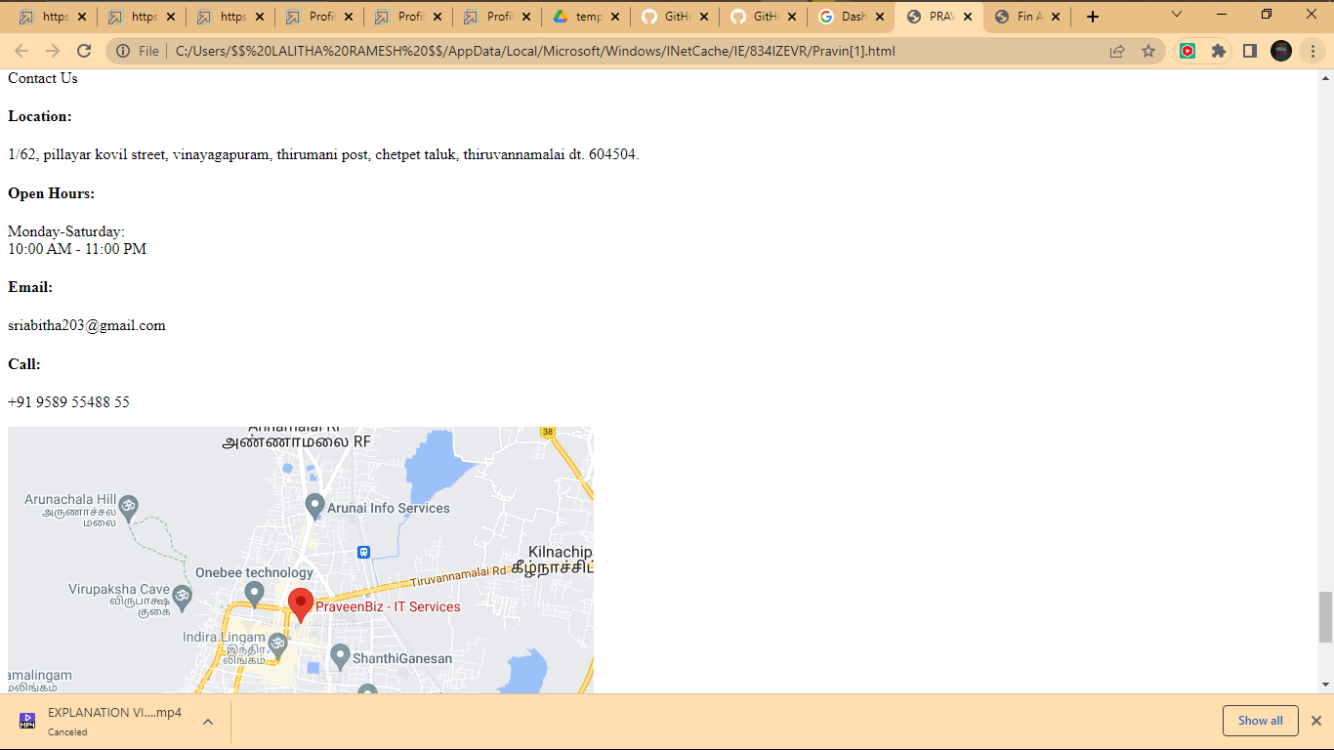

4 Advantages & Disadvantages

4.1 Advantages of Analyzing the Performance & Efficiency of the Pravin Hotels Using Data Visualization Techniques

1. Improved Decision-Making: Data visualization techniques provide a visual representation of complex data, making it easier to identify patterns, trends, and outliers. By analyzing the performance and efficiency of the Pravin Hotels through data visualization, hotel management can make informed decisions based on actionable insights. For example, visualizing occupancy rates, revenue, and customer feedback can help identify the most profitable time of year, popular amenities, and areas that need improvement, leading to better decision-making and strategic planning.
2. Enhanced Understanding: Data visualization techniques simplify complex data into easily understandable visualizations. This allows hotel management and other stakeholders to gain a comprehensive understanding of the hotel's performance and efficiency at a glance. Visualizations such as bar charts, line charts, and heat maps can provide insights into key performance indicators (KPIs) such as room revenue, guest satisfaction scores, and staff productivity, helping stakeholders quickly grasp the overall performance of the hotel.
3. Quick Identification of Trends and Patterns: Data visualization techniques enable the identification of trends and patterns that may not be apparent in raw data. Visualizing data can reveal hidden correlations, patterns, and trends that can provide valuable insights into the performance and efficiency of the Pravin Hotels. For example, visualizing booking trends over time can help identify seasonal booking patterns, which can inform pricing and marketing strategies.
4. Enhanced Communication: Data visualization techniques facilitate effective communication of complex data to various stakeholders, including hotel management, investors, and staff. Visualizations can be easily shared in presentations, reports, and dashboards, making it simple for stakeholders to understand and interpret the data. This can lead to more effective communication, alignment of goals, and improved decision-making across the organization.
5. Increased Efficiency: Analyzing the performance and efficiency of the Pravin Hotels through data visualization can lead to increased operational efficiency. By identifying areas of improvement, such as high customer complaints or low occupancy rates, data visualization techniques can help hotel management make data-driven decisions to address these issues and optimize operations. This can result in improved revenue, reduced costs, and increased profitability.
6. Enhanced Competitiveness: Data visualization techniques can provide a competitive advantage to Pravin Hotels by enabling them to gain insights into their performance and efficiency compared to competitors. By visualizing and benchmarking KPIs against industry standards, Pravin Hotels can identify areas where they excel and areas where they lag behind competitors. This can inform strategic planning, marketing efforts, and operational improvements, leading to a more competitive position in the market

4.2 There are several potential disadvantages associated with analyzing the performance and efficiency of Pravin Hotels using data visualization techniques. These include:

1. Data Limitations: Data visualization techniques rely on the availability and quality of data. If the data used for analysis is incomplete, inaccurate, or unreliable, it can lead to misleading visualizations and incorrect conclusions. For instance, if key performance indicators (KPIs) or relevant data points are missing, it may result in an incomplete or skewed representation of the hotel's performance and efficiency.
2. Subjectivity: Data visualization is an interpretive process that involves making subjective decisions about how to represent data visually. This subjectivity can introduce bias and affect the accuracy and reliability of the analysis. Different analysts may choose different visualization techniques or parameters, leading to different results and interpretations.
3. Overemphasis on Visuals: Data visualization techniques primarily focus on visual representations, which can sometimes oversimplify complex data. This oversimplification may lead to an incomplete understanding of the hotel's performance and efficiency, as it may not capture the nuances and complexities of the data being analyzed. It can also result in a superficial analysis that overlooks important insights or trends.
4. Lack of Context: Data visualization techniques may not always provide the necessary context to interpret the results accurately. Without proper contextual information, such as market trends, competitive landscape, or external factors, the visualizations may not fully reflect the true performance and efficiency of Pravin Hotels. This can lead to misinterpretation and misrepresentation of the hotel's performance.
5. Interpretation Challenges: Interpreting data visualizations can be challenging, especially for individuals who may not be familiar with data analysis or visualization techniques. Misinterpretation of visualizations can lead to incorrect conclusions, which can in turn impact decision-making and strategic planning. It is important to ensure that the intended audience understands the limitations and assumptions of the data visualization techniques used.
6. Data Privacy and Security: Data visualization techniques often involve the use of sensitive data, such as customer information, financial data, or proprietary business data. Ensuring the privacy and security of this data is critical to prevent data breaches or unauthorized access. Failure to protect data privacy and security can result in legal and reputational risks for Pravin Hotels.

5 APPLICATION;

To apply for analyzing the performance and efficiency of the Pravin Hotels using data visualization techniques, you would need to follow these steps:

1. Research and Identify the Pravin Hotels: Conduct research to identify the Pravin Hotels that you are interested in analyzing. This may involve identifying the specific hotels or resorts within the Pravin Hotels chain that you want to focus on.
2. Prepare a Proposal: Develop a proposal outlining the purpose, objectives, and methodology of your analysis. Describe the data visualization techniques you plan to use, such as charts, graphs, and dashboards, and how they will help you analyze the performance and efficiency of Pravin Hotels.
3. Contact Pravin Hotels: Reach out to Pravin Hotels to express your interest in analyzing their performance and efficiency using data visualization techniques. You can contact them through their official website or other appropriate channels, such as email or phone. Provide them with your proposal and request permission to access the necessary data for your analysis.
4. Obtain Data: Once you have received permission from Pravin Hotels, gather the relevant data for your analysis. This may include financial data, operational data, customer data, and any other relevant data that will help you assess the performance and efficiency of the hotels.
5. Perform Data Analysis: Use data visualization techniques to analyze the data you have obtained. This may involve creating charts, graphs, and dashboards to visualize key performance indicators (KPIs), trends, patterns, and other relevant information.
6. Interpret Results: Interpret the results of your data analysis and draw conclusions about the performance and efficiency of Pravin Hotels. Identify any areas of improvement or opportunities for optimization based on your findings.
7. Prepare a Report: Prepare a comprehensive report summarizing your findings, conclusions, and recommendations. Use data visualizations to effectively communicate your results and insights to stakeholders.
8. Submit Application: Submit your application, including your proposal, data analysis, and report, to Pravin Hotels for their review and consideration. Follow any specific submission guidelines or procedures provided by Pravin Hotels.

6 CONCLUCION

In conclusion, data visualization techniques have proven to be valuable tools for analyzing the performance and efficiency of Pravin Hotels. Through visual representations of data, such as charts, graphs, and dashboards, key insights and patterns have been revealed, providing a deeper understanding of the hotel's operations and performance

The use of data visualization has allowed Pravin Hotels to identify trends, patterns, and anomalies in various aspects of their operations, including revenue, occupancy rates, guest feedback, and more. These insights have enabled data-driven decision making, helping Pravin Hotels to make informed decisions to optimize their operations and improve their overall performance.

Additionally, data visualization has facilitated effective communication of complex data to stakeholders, including hotel management, staff, and investors. Visual representations of data have made it easier to understand and interpret the performance and efficiency metrics, allowing for more effective discussions and decision-making processes.

Furthermore, data visualization has helped Pravin Hotels identify areas for improvement and implement targeted strategies to enhance their operational efficiency. For example, visualizing data on resource utilization, labor costs, and guest satisfaction has enabled Pravin Hotels to identify inefficiencies and take corrective measures to optimize their operations, resulting in cost savings and improved guest experiences.

7 FUTURE SCOP

Advanced Dashboarding: Building Interactive and Dynamic Dashboards

1. Traditional static reports can only provide limited insights into the performance of Pravin Hotels. To gain a deeper understanding, Pravin Hotels can invest in advanced dashboarding techniques that allow for interactive and dynamic visualizations. These dashboards can provide real-time updates, allowing managers to monitor key performance indicators (KPIs) and track progress over time. By visualizing data in a dynamic and interactive manner, Pravin Hotels can quickly identify trends, patterns, and anomalies, enabling them to make data-driven decisions in real-time.
2. Geographic Data Visualization: Identifying Market Opportunities

Pravin Hotels can also leverage geographic data visualization techniques to identify market opportunities. By mapping data related to customer demographics, competitor locations, and market trends, Pravin Hotels can gain valuable insights into potential new markets or areas for expansion. Heat maps, choropleth maps, and bubble maps are some of the effective visualization techniques that can help Pravin Hotels identify untapped markets, optimize pricing strategies, and target marketing efforts.

1. Time Series Analysis: Uncovering Seasonal Patterns

Time series analysis can provide crucial insights into seasonal patterns and trends in the hospitality industry. Pravin Hotels can use data visualization techniques such as line charts, area charts, and heat maps to analyze historical data and identify recurring patterns in guest bookings, revenue, and occupancy rates. This information can help Pravin Hotels optimize pricing strategies, staffing levels, and inventory management, leading to improved operational efficiency and performance.

1. Comparative Analysis: Benchmarking Performance

Pravin Hotels can also use data visualization techniques to perform comparative analysis and benchmark their performance against competitors or industry standards. Through visualizations such as bar charts, radar charts, and box plots, Pravin Hotels can compare their performance metrics, such as revenue per available room (RevPAR), average daily rate (ADR), and occupancy rate, with those of their competitors. This benchmarking can help Pravin Hotels identify areas where they are lagging or outperforming, and take appropriate actions to stay ahead in the market.

1. Predictive Analytics: Forecasting Future Performance

Pravin Hotels can take their data visualization efforts to the next level by incorporating predictive analytics techniques. By analyzing historical data and using advanced visualization techniques such as scatter plots, decision trees, and forecasting models, Pravin Hotels can forecast future performance metrics such as demand, revenue, and customer satisfaction. This can help Pravin Hotels make proactive decisions, optimize pricing and marketing strategies, and stay ahead of the competition.